[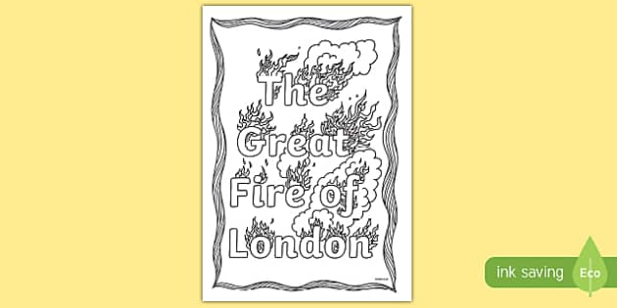](http://www.google.co.uk/url?sa=i&rct=j&q=&esrc=s&source=images&cd=&cad=rja&uact=8&ved=0ahUKEwjTvdXh1ZzUAhVEL8AKHYiPDhEQjRwIBw&url=http://www.twinkl.co.uk/resource/t-c-7640-the-great-fire-of-london-colouring-page&psig=AFQjCNH4TNyZLgbrgepFiAZwgPNmaioQyA&ust=1496404859277267)

[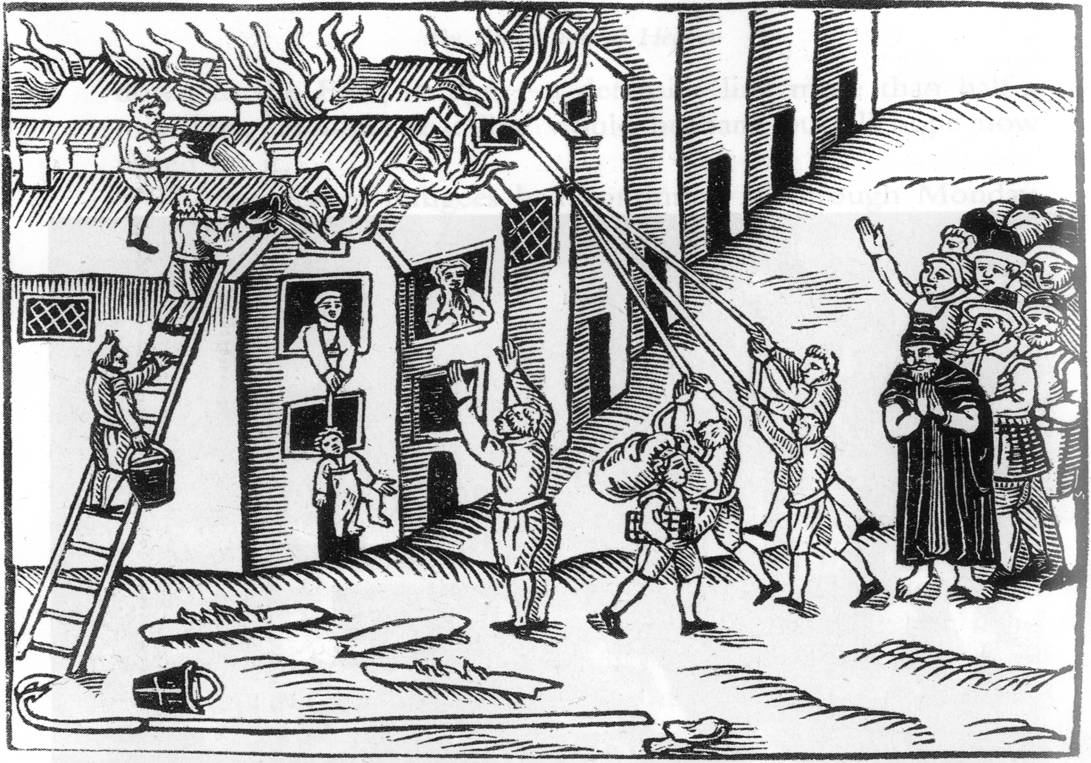](https://www.google.co.uk/url?sa=i&rct=j&q=&esrc=s&source=images&cd=&cad=rja&uact=8&ved=0ahUKEwiikuza1pzUAhVKJsAKHRpABpAQjRwIBw&url=https://www.theschoolrun.com/homework-help/great-fire-london&psig=AFQjCNH4TNyZLgbrgepFiAZwgPNmaioQyA&ust=1496404859277267)