Hello to all in P6!
Our topic in World Around Us was to study ‘The Vikings’. We really enjoyed doing this in class and we expressed what we knew about The Vikings in art, ICT, pieces of writing and mind maps.
I have included a research map on the next page and I would love for you to fill the map with all of your knowledge on The Vikings.
Remember to think about-
- Where The Vikings came from.
- Where did they go.
- How did they get there- Viking Long ships.
- What type of houses did they live in?
- What did they eat and drink?
- What weapons did they use- remember in class when you stuck in a picture of each weapon into your books and you told me two facts about each?
- What was life like for a Viking child- think about your diary entry that you completed in class!
- Include any other weird and wonderful facts that you have! I know in P6 that the weirder the fact, the more likely you are to remember it!!

You could then decorate your research map with some Viking Runes!
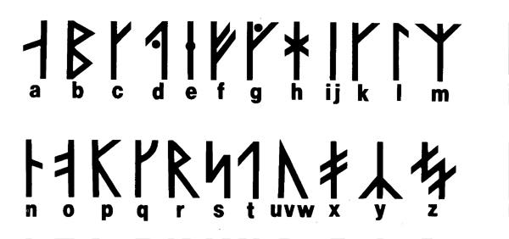
Have fun!
Miss McParland

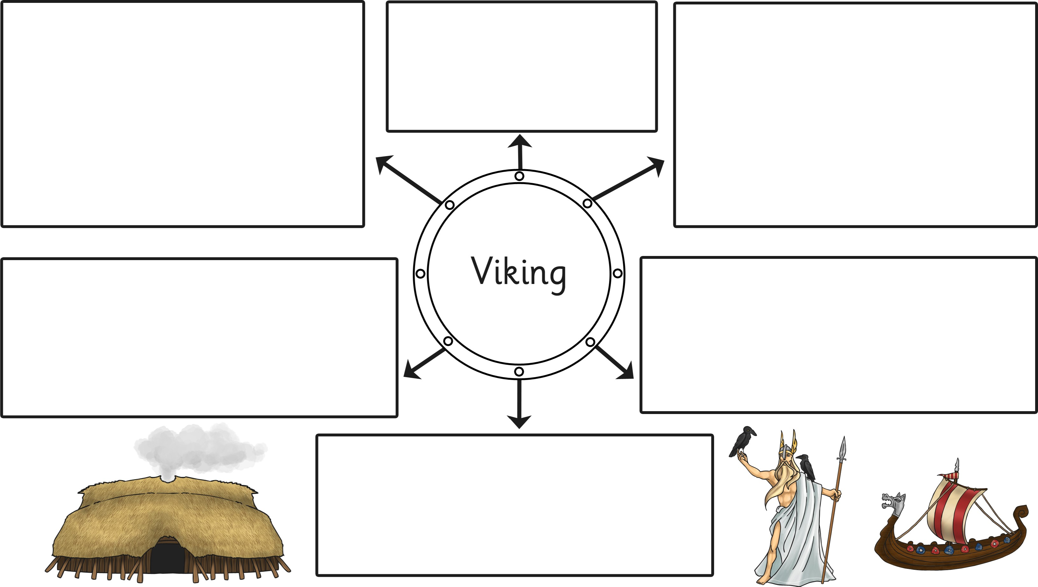

My Viking Research Map
Fill the map with facts or pictures from your research and make links between any that have a connection. You could include questions you might research another day.

