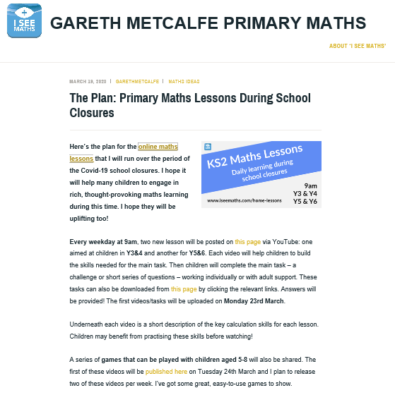
http://www.iseemaths.com/home-lessons/

