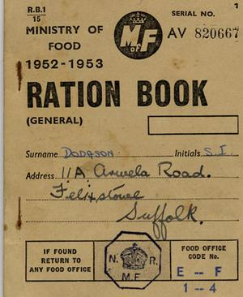
Clothing Rationing
Along with food clothing was also rationed during World War 2, although not right at the start of the war unlike food. Each adult and child had 48 coupons to spend each year and the clothes that they bought had to last as long as they could manage.
ITEM | Number of Coupons- Men | Number of Coupons- Women | Number of Coupons- Children
Raincoat | 16 | 15 | 11
Overcoat | 7 | 7 | 4
Jacket | 13 | 12 | 8
Shirt/Blouse | 5 | 4 | 3
Jumper/Cardigan | 5 | 5 | 3
Trousers | 8 | 8 | 6
Shorts | 3 | 3 | 2
Skirt |  | 8 | 6
Boots/Shoes | 7 | 5 | 3
Nightdress/Pyjamas | 8 | 6 | 6
Underpants/Knickers/Vest | 3 | 3 | 2
Socks/ Stockings | 2 | 2 | 1
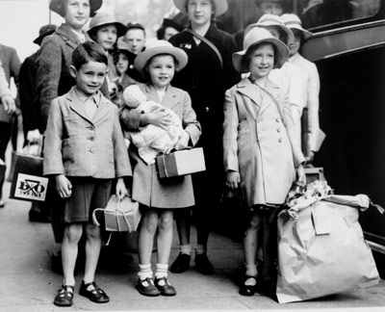
Spending Your Rations
Imagine: Your house has been bombed and you have nothing left. You are about to be evacuated and you have to buy enough clothes to take with you; they need to last you as long as possible.
You have only 48 coupons! Will you have enough?

What do you need to buy? How many coupons do you have to hand over?

_________________________ ________________________________________________

_________________________ ________________________________________________

_________________________ ________________________________________________

_________________________ ________________________________________________

_________________________ ________________________________________________

_________________________ ________________________________________________

_________________________ ________________________________________________

_________________________ ________________________________________________

_________________________ ________________________________________________

Did you have enough coupons?
How many more will you need?
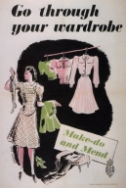

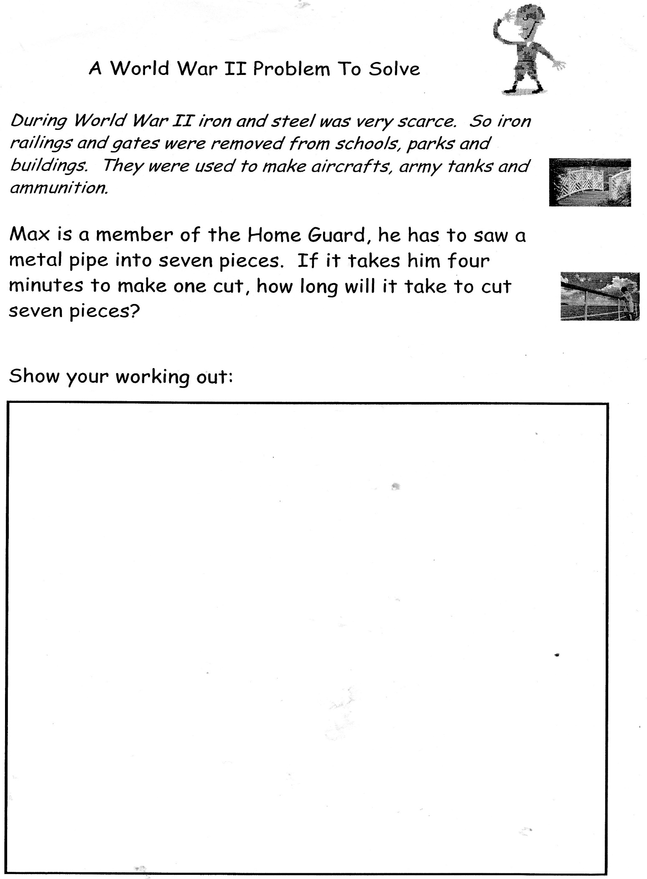
Rationing

