**Group 1**

**Hatching chicks ch**

The children came back from the ditch. They had seen a batch of eggs the chickens had laid. One child fetched a torch as it was pitch black at night. They took turns watching, waiting for the eggs to hatch. At lunch time the child came in to the kitchen clutching a tiny chick. They built a hutch for the baby chicks and took pictures of them. They will choose names for the chicks soon.

MCj04081960000[1]

**Fluffy fish f**

The fluffy fish sniffed and huffed while playing golf. He was full of water and food and found it hard to play. He phoned his friend to come and help. He felt such a fool when he woke up from his dream.

MCj04175800000[1]

**Gus g**

Gus hugged his good girl and said goodbye. He watched her play a game with her dog. The dog wagged his tail. The girl giggled. Gus joined the gang of gold diggers who are going to the foggy river.

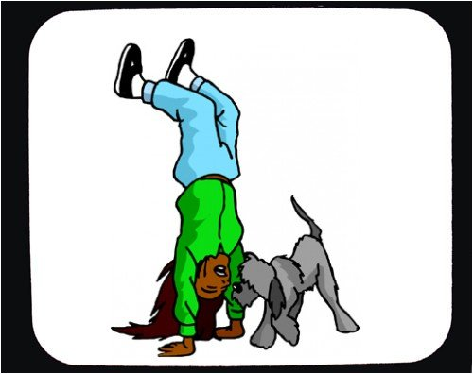

**Who has a horse h wh**

Who has a horse in a house? Who is happy to help clean the mess it would make? Perhaps the horse will go outside and hunt. For whom shall it hunt? I hope it does not fall down a hole.

MCj04174740000[1]

**Jeans with gems j**

In June I jump for joy. My birthday is July 1st – the first day of the summer holidays. I want jeans with gems on the edges and gel for my hair. I will have sausages and fudge cake.

MCj04382450000[1]

I met a man m

I met a man in summer.

He said he was a drummer.

My mummy said he’s mad

As he smiled and then looked sad.

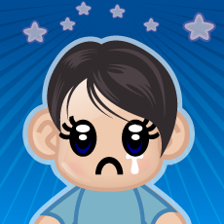

**My nanny is nice n**

My nanny is nice. She has funny knees that click and groan. She sits in the garden on sunny days and knits. At night she sits near me and tells me stories. My granny is grand.

MCj02405690000[1]

**Ten little kittens t**

Today ten little kittens rattled their tails. Rat a tat tap.

They rattled their tails to the beat of the dogs bark -

Tap tap, tap tap.

They rattled their tails as they jumped and looked about.

Their tails are now getting better.

It will take time to mend their sore tails!

**MCj04381670000[1]**

While w wh

While the white witch walked,

The wise woman woke

As the wild water washed

The watching swan away.

MCj04247120000[1]